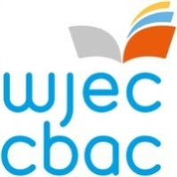
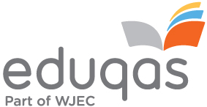

GCE German Reviser

WJEC is looking to recruit a reviser for A-level and AS German. The role will involve the Reviewing of examination related documentation for WJEC and/or Eduqas GCE qualifications in Wales and/or in England.

Responsibilities:

• review the initial drafts of question papers, mark schemes, assessment grids and any resource material, ensuring each question is appropriate and completely within the specification;

• ensure that the questions have not been set in previous examinations;

• take into account feedback from previous examination sessions, including recommendations from relevant monitoring reports where these are available;

• check the marking scheme for each question is comprehensive, accurate and appropriate;

• provide detailed written comments on the initial drafts of all questions, their associated marking schemes, resource material and assessment objective grids;

• complete the required report forms and forward them to WJEC;

• participate in meetings of the Question Paper Evaluation Committee, at which the draft question papers and mark schemes are discussed in detail;

• carefully proof read subsequent proofs of materials to ensure the question papers and associated resource materials are error free.

- Successful candidates are required to maintain the confidentiality of the work undertaken.

Experience/qualifications needed
- degree in the subject specific to this qualification or a related subject
- relevant assessment and teaching experience
- the ability to work well under pressure

For further information, please contact Naomi Taylor on naomi.taylor@wjec.co.uk The closing date for applications is Monday, 10 May 2021.

How to apply:
If you wish to apply for the role and are not currently working for the WJEC please go to https://appointees.wjec.co.uk and click 'Apply to become an Examiner' to fill out the application form.

If you currently work for WJEC, please log in to your Appointees Management Portal Account and click on the 'My Application' icon on the home screen. Please ensure you add the role of Reviser for GCE German on the 'subject area' tab and complete all the other fields of the application.

If you require any further assistance please contact:-

Rob Reynolds
rob.reynolds@wjec.co.uk
029 2105 7511

