Samarium-Neodymium Dating (AS Topic 3: Time and Change - Key Idea 2b)

(A Level Topic F3: Time and Change - Key Idea 2b)
Samarium (Sm) and Neodymium (Nd) are two of the 15 rare earth elements (lanthanides) that exist in small but measurable quantities in most rocks and minerals. The radioactive isotope of Sm with an atomic weight of 147 (¹⁴⁷Sm) decays to an isotope of Nd with an atomic weight of 143 (¹⁴³Nd). This has a very long half-life of 106 billion years, so this technique is best suited for rocks that are hundreds of millions or billions of years old. Nd also exists as the stable isotope ¹⁴⁴Nd, against which ¹⁴³Nd and ¹⁴⁷Sm are measured. It has been possible to date rocks precisely using this method because the Sm and Nd content of their constituent minerals have not been modified since the rock crystallised.
A 2.7-billion-year old gabbro is composed of plagioclase, and two types of pyroxene (clinopyroxene and orthopyroxene). When the three minerals simultaneously crystallised, they possessed identical ratios of ¹⁴³Nd and ¹⁴⁴Nd (because isotopes of the same element behave essentially the same way in chemical processes such as crystallisation) but different concentrations of Nd and Sm. Thus, when they first crystallise, the individual minerals (and whole rock samples) would plot as a horizontal, straight line on a graph of ¹⁴³Nd /¹⁴⁴Nd versus ¹⁴⁷Sm /¹⁴⁴Nd. (Figure 1). As ¹⁴⁷Sm decays to ¹⁴³Nd with time, the ratios for the mineral and whole-rock samples on both axes will change as shown; the ratio of the ¹⁴³Nd to ¹⁴⁴Nd will become larger with time, while the ratio of ¹⁴⁷Sm to ¹⁴⁴Nd will become smaller. For any given period of time, the change in ¹⁴³Nd /¹⁴⁴Nd and ¹⁴⁷Sm /¹⁴⁴Nd ratios will be greater for minerals with a higher concentration of the parent ¹⁴⁷Sm isotope (e.g. pyroxene), than a lower concentration (e.g. plagioclase). In this way, the slope of the line formed (isochron) is proportional to age.
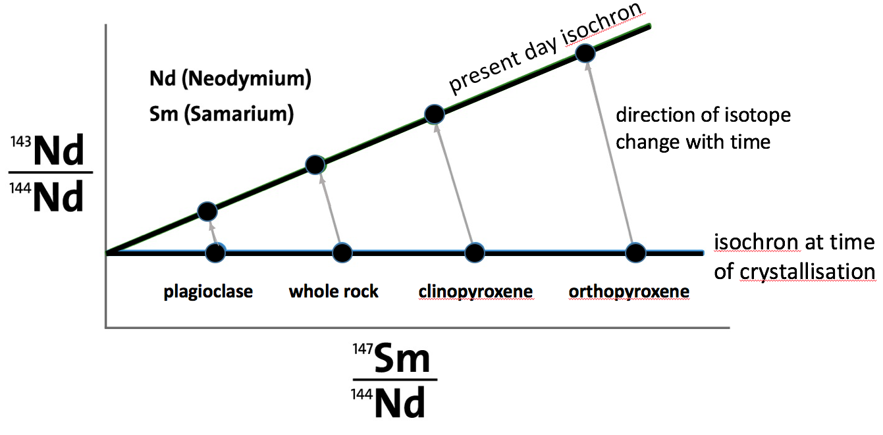
Figure 1. Dating Graph: The minerals plagioclase and both pyroxenes, (along with a whole rock sample) have the same ratio of ¹⁴³Nd /¹⁴⁴Nd at the time of crystallisation (horizontal line). Over time, ¹⁴⁷Sm decays to ¹⁴³Nd and the mineral compositions change, as indicated by the connecting arrows. The isochron thus rotates with time, and its slope is proportional to the rock's age.

