Level 1 / 2 Performing Arts
(Technical Award)
Skills Audit

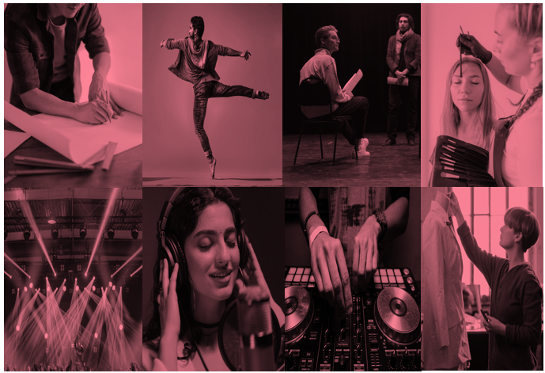
Please note that there is no requirement to use these and no expectation to have them included as part of the evidence submitted by learners. They are intended solely as a teaching resource should you wish to use them. They should not replace learners’ own reflection on their skills as part of development logs, but may be a useful starting point, particularly when selecting pieces of repertoire appropriate for their skills and interests.
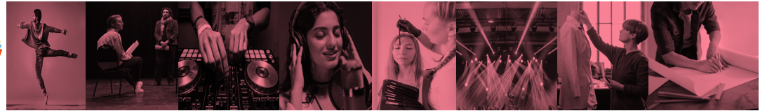
Acting / Devised Drama
Skill |  |  |  | Action to Improve
Accuracy
Coordination
Communication
Control
Dealing with mistakes
Interpretation
Interpretation and development of character
Clarity of chosen style
Pitch
Tone
Pace
Accent
Physicality
Eye Contact
Gesture
Use of proxemics
Interaction with other performers
Use of blocking / understanding different stage types
Structure, form and style

Music / Composition
Skill |  |  |  | Action to Improve
Accuracy
Coordination
Communication
Control
Dealing with mistakes
Interpretation
Technical control
Rhythm and pitch
Dynamics and balance
Expression
Use of melody
Use of harmony
Use of tonality
Use of form and structure
Exploration of sonority
Use of texture
Use of metre
Use of pitch appropriate to voice or instrument
Use of articulation

Musical Theatre / Choreography
Skill |  |  |  | Action to Improve
Accuracy
Coordination
Communication
Control
Dealing with mistakes
Interpretation and development of character
Singing vocal techniques, acting through song
Dance technique, application of style
Acting: Movement, voice, character
Interconnection between the disciplines
Use of actions
Use of space
Use of dynamics
Relationships
Motif
Narrative
Unison
Canon
Use of structure and form – binary, ternary

Music Technology / Composition Using Technology
Skill |  |  |  | Action to Improve
Accuracy
Coordination
Communication
Control
Dealing with mistakes
Interpretation
Technical control
Dynamics and balance
Effective use of chosen technology
Expression
Mixing and beat matching
Elements of music
Effects
Sampling
Panning
Sequencing
Live and recorded sound
Scores

Costume Design
Skill |  |  |  | Action to Improve
Understanding style

Use of colour to create mood
Use of appropriate materials
Use of texture

Creating a pattern

Measuring performers

Sewing skills

Use of equipment

Dyeing

Communicating ideas

Interpreting text

Creativity

Symbolism

Set Design
Skill |  |  |  | Action to Improve
Understanding style
Different stage types
Use of symbolism
Creating mood, atmosphere and location
Sightlines
Use of levels
Consideration of entrances and exits
Scale
Scale drawing / modelling
Construction methods
Communication
Creativity

Lighting Design
Skill |  |  |  | Action to Improve
Communication
Creativity
Use of colours to create mood / location
Understanding performance style
Rigging lights
Use of lantern types
Programming
Use of cue sheets
Creating effects
Use of focus
Use of angles
Use of gobos
Use of effects, for example creating shadows, using barn doors
Positioning

Sound Design
Skill |  |  |  | Action to Improve
Creating mood and atmosphere
Creating location
Understanding performance style
Amplification of voices
Use of live sound
Use of recorded sound
Editing
Sound effects
Diegetic and non diegetic sound
Creating a cue sheet
Communicating ideas
Use of equipment
Programming

Make Up and Hair Design
Skill |  |  |  | Action to Improve
Character analysis
Use of materials
Use of tools
Application techniques highlighting
Application techniques shading
Application techniques emphasis
Application techniques sculpting
Application techniques prosthetics
Special effects
Facial analysis
Choice of suitable products
Facial analysis
Wig / hair design
Communicating ideas
Creativity

