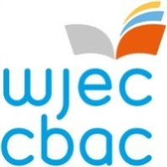
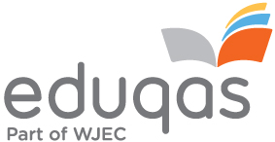

Principal Moderator
Language Pathways
Role Profile and Application Form

Purpose:
WJEC is recruiting a Principal Moderator to support the moderation and standardisation of Language Pathways qualifications from Entry Level to Level 2. Language Pathways qualifications are available in French, German, Spanish, Italian, Mandarin, Japanese and Cornish. Successful candidates will be responsible for the assessment of qualifications in England and Wales.

The Principal Moderator has the following responsibilities:
Responsibilities:

- lead the moderator training conference online

- monitor the standards of moderation for all the moderators, including, where necessary, any assistant moderators, and take appropriate steps to ensure accuracy and consistency

- standardise the marking across all centres and check moderator reports

- advise on the appointment, training and reappointment, where necessary of moderators

- provide evidence for the confirmatory award meeting, advise members on how the units functioned and make recommendations

- submit an evaluation report on the performance of the units

The Principal Moderator needs to be available for a minimum of four days a year which may be during term time, at weekends and during holiday time. Release payment to centres is available where necessary. This will enable the post holder where applicable to lead the moderator training conference.
Experience/qualifications needed
- degree in one of the languages specific to this qualification
- knowledge of at least one other language in the Language Pathways portfolio
- relevant assessment and teaching experience
- experience of managing people
- the ability to work well under pressure
For further information, please contact Claire Parry 029 20265402 claire.parry@wjec.co.uk The closing date for applications is Friday, 4th June 2021.
How to apply:
If you wish to apply for the role and are not currently working for the WJEC please go to https://appointees.wjec.co.uk and click 'Apply to become an Examiner' to fill out the application form.
If you currently work for WJEC, please log in to your Appointees Management Portal Account (using your new username) and click on the 'My Application' icon on the home screen. Please ensure you add the role of Principal Moderator for Language units Pathways on the 'subject area' tab and fill in all the other fields of the application.

If you require any further assistance in completing the application please contact:-

Rob Reynolds  rob.reynolds@wjec.co.uk  0290 265 050 | or | Beth Edgar  beth.edgar@wjec.co.uk  02920 265 476

