WJEC Eduqas A level
Geology Specification

“New models of the ocean crust”

Topic F4: EARTH STRUCTURE AND GLOBAL TECTONICS
Key Idea 1: The Earth has a concentrically zoned structure and
composition
Knowledge and  understanding | Geological techniques and skills | Comments
b. The crust is a thin layer  of distinctive composition  overlying the mantle;  continental and oceanic  crust can be recognised  and distinguished by their  differing thicknesses,  composition and  structure. | Interpretation of geophysical  data on crustal structure  (seismic, gravity, magnetic)  from continental and oceanic  areas.  Analysis of ocean drilling data  to re-interpret the Mohorovičić  discontinuity (Moho) at the  base of the crust (e.g. Joides  Resolution 360). | Candidates should be given  the opportunity to evaluate  and validate the new  knowledge obtained from  current ongoing scientific  research.  • the significance of  serpentinite at the  Moho discontinuity

Topic G1 : ROCK FORMING PROCESSES
Key Idea 1: The generation and evolution of magma involves
different processes
Knowledge and  understanding | Geological techniques and skills | Comments
c. The formation of  magma chambers  under ocean ridges  and rises can be  interpreted from  models. | Analysis of ocean survey  data to investigate current  models of how oceanic  ridges (particularly mid  ocean ridges-MORs) are  formed (e.g. RRS James  Cook – 2016). | Candidates should be familiar  with new models of ocean ridge formation (using data from seismic tomography and deep ocean drilling) involving  • symmetrical and  asymmetrical spreading  • ocean core complexes (OCC)  • the significance of  serpentinite.

The significance of Serpentinite

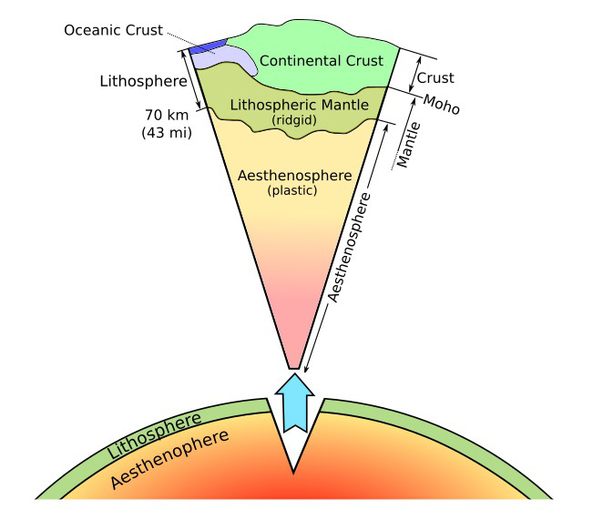
The Earth is made of layers based either on differences in chemistry (crust, mantle and core) or mechanical behaviour (Lithosphere -strong, Asthenosphere - weak)
Moho
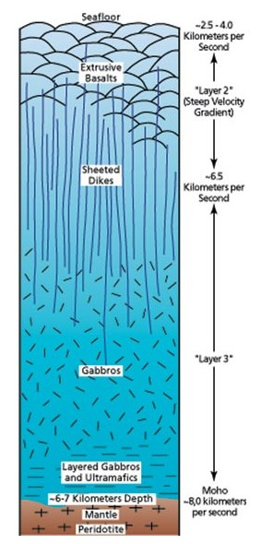

Oceanic crust is made largely of basaltic and gabbroic rocks. These rocks are usually found in distinct layers with basalt at the surface and then a layer of sheeted dykes that bring magma to the surface, followed by gabbro (see diagram).

Beneath the gabbro the mantle is composed of peridotite that mainly consists of the mineral olivine. At the Mid Atlantic Ridge (MAR) the cracks, fissures and faults in the crust allow seawater to sink where it is warmed before rising back to the surface by convection. These hydrothermal fluids react with olivine in peridotite to form the mineral serpentine and the rock serpentinite which has similar seismic properties to gabbro. In addition, serpentinite may have the effect of lubricating faults such as the shallow detachment faults of ocean core complexes (OCC). Shallow detachment faults are likely areas where mantle peridotite is brought nearer to the ocean surface. The lubricating nature of serpentinite probably exacerbates the rate of slippage of the fault resulting in asymmetric spreading (see below). The mantle peridotite reacts with the warm seawater along the fault, more serpentinite is formed and the slippage continues, bringing more peridotite to the surface. And so the cycle continues. Serpentinite is also likely to be important in subduction zone processes.

What is the Moho?
Traditionally, the boundary between the crust and the mantle - the Moho - represents a change in composition from gabbro to peridotite which accounts for the significant increase in seismic wave velocities. However, recent scientific work suggests that our long-held assumptions about the structure of ocean crust may be flawed, particularly at slower-spreading ridges. The increase in seismic wave velocities at the base of seismic layer 3 may not reflect the crust-mantle boundary but rather the lower limit of seawater penetration into mantle, above which mantle peridotite has altered to serpentinite.
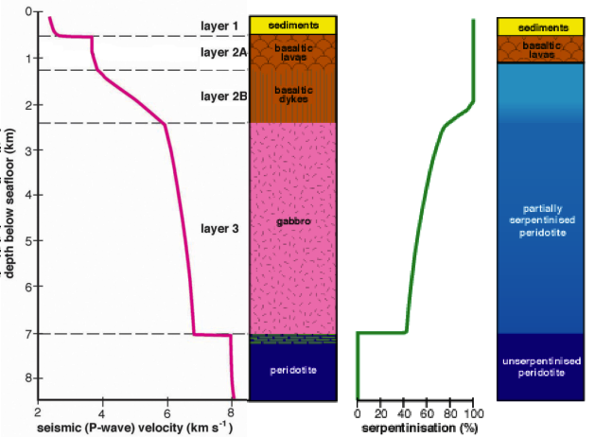

Moho?

Two models to account for changes in seismic velocities with depth in oceanic “crust”

The figure above shows there is more than one way to explain the velocity structure of seismic layer 3. We cannot use geophysics alone to deduce lithology, therefore we do not know what proportion of the two thirds of the surface of the planet covered by oceanic lithosphere is actually formed of this 'serpentinite crust'. In essence, we now realise we know a lot less about the fundamental workings of the planet than we thought we did.

All of the above discussion presents a compelling argument as to why we still need to mount expeditions such as the ongoing 'SloMo' project (International Ocean Discovery Program [IODP] Expedition 360; http://iodp.tamu.edu/scienceops/expeditions/indian_ridge_moho.html
which aims to answer the question “Does the Moho represent the crust-mantle boundary in an alternative 'serpentinite' ocean crust model?” by drilling a hole through the Moho on the SW Indian Ridge. The Joides Resolution 360 team have identified a place ('Atlantis Bank', at 57°E 32°S, adjacent to the Atlantis II transform fault zone) at which they have good reason to believe the Moho is a serpentinisation boundary, perhaps beneath a collage of gabbro bodies and partially serpentinised peridotite. At about 5 km below the seafloor the Moho is slightly more accessible here than elsewhere, though the technological challenges of reaching it nevertheless remain profound. Expedition 360 (November 2015 to January 2016) succeeded in drilling ~800 m (all in gabbro) towards the target. Hole U1473A is ready to be reoccupied but it is likely to be several years before they are able to get access to a drill ship once more, return to Atlantis Bank, and attempt to answer gain further answers.
Symmetric and Asymmetric Spreading

About 10 years ago, scientists discovered that there is a new mode of seafloor spreading operating in some 50% of the Mid-Atlantic Ridge. Whereas the ‘classical’ mode of spreading is symmetric, this new mode is highly asymmetric.

The process by which the mantle is brought to the seafloor and thereby serpentinised represents a very different mechanism of seafloor spreading than conventional igneous accretion. Giant extensional 'detachment' faults that pull the plates apart without producing an igneous crustal layer have been discovered at slower-spreading ridges. These structures form the subject of the separate case study arising from RRS James Cook cruise JC132.

Whereas it was thought probable that the conventional ocean crust model more or less still applies at faster-spreading ridges such as the East Pacific Rise, and therefore floors the Pacific, it has been suggested that up to half of all seafloor formed at slower spreading rates (the Atlantic, and most of the Indian Ocean) might contain significant proportions of serpentinite. Potentially, therefore, 'serpentinite crust' could cover at least a sixth of the surface of the planet. We simply don't know.

Symmetric spreading
In the symmetric mode, as the plates separate, ductile asthenosphere wells up to fill the gap, and partially melts (about 10%). The melt rises and solidifies to form the gabbro plutons, sheeted dykes and basaltic lavas of the crust. The melt may accumulate in one or more small mid-crustal magma chambers on the way up. Once the crust has formed, the stresses pulling the plates apart produce normal faults, with displacements of ~100m, which add some 5-10% of strain. The structures of both plates are very similar, as are their accretion or spreading rates; new material is added equally to both sides.

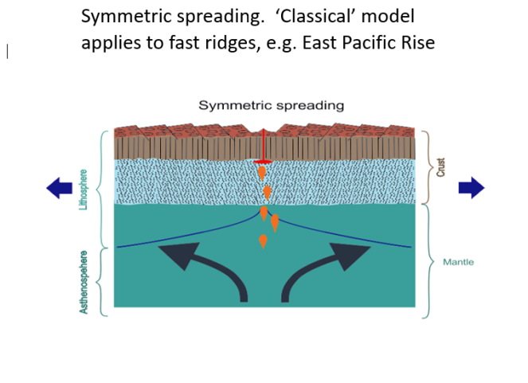
Asymmetric spreading
The newly discovered asymmetric mode is quite different. Such faults may penetrate right through the lithosphere (detachment fault), and accumulate displacements of tens of kilometres over millions of years (see diagram). The hanging wall plate (right-hand one in the diagram) receives less melt than normal and so its crust is thinner. The footwall plate (on the left) is formed by pulling mantle material up. If all of the plate separation is taken up by slip on the detachment fault, then no new material will be added to the hanging wall plate, and spreading will be 100% asymmetric. The resulting seafloor landform of an Ocean Core Complex (OCC) is formed. The one studied by the JC132 at 13ºN in the Atlantic Ocean is about the size of Ben Nevis.
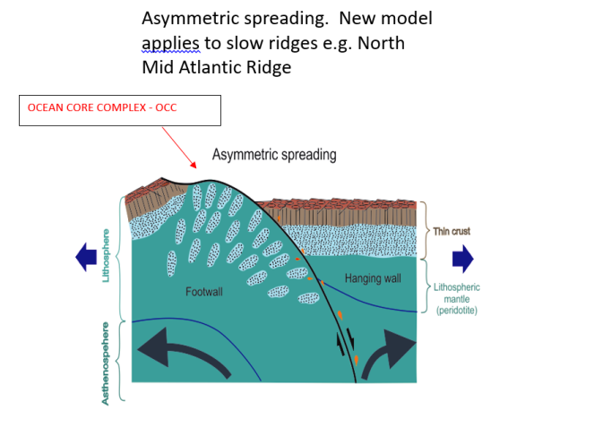
(Diagrams created for the Teacher At Sea by Professor Roger Searle – the diagrams have extreme vertical exaggeration)

Oceanic core complexes are the uplifted footwalls of very large, offset, low-angle normal faults that exhume lower crust and mantle rocks onto the seafloor at slow-spreading ridges. Although it is suggested on the basis of numerical modelling that they form during periods of relatively reduced magma supply, little is known about how they initiate and become inactive, nor why only certain normal fault systems develop into core complexes. Sonar/bathymetric profiler survey and sampling study of the Mid-Atlantic Ridge near 13°N show that core complex detachment faults initiate as high-angle (65° ± 10°) normal faults, no different from surrounding valley-wall faults and, like them, rapidly flatten to dips of ∼ 30° in response to flexural unloading. However, on certain structures, slip continues rather than being relayed inward onto a new normal fault. Runaway displacement appears to be triggered primarily by local waning of magma supply below a critical threshold, seawater penetration and talc formation along the fault zones. Spreading becomes markedly asymmetric when the core complexes are active, and volcanism is suppressed or absent. When the asymmetry is such that the detachments accommodate more than half the total plate separation the active faults migrate across the axial valley. As a consequence, magma is emplaced into and captured by the footwall of the detachment fault rather than being injected into the hanging wall, explaining the frequent presence of gabbro bodies and other melt relicts at oceanic core complexes. Core complexes are ultimately terminated when sufficient magma is emplaced to overwhelm the detachment fault.

Acknowledgements and Further research

Adapted from

- What is the Moho? Ocean crust seismic structure and lithology practical exercise: developed by Professor Chris MacLeod - Cardiff University Co-Chief Scientist – IODP Expedition 360. This exercise and further information is available at: www.seafloorspreading.com

- Life cycle of oceanic core complexes: MacLeod, C. J.; Searle, R. C.; Murton, B. J.; Casey, J. F.; Mallows, C.; Unsworth, S. C.; Achenbach, K. L.; Harris, M. (2009) in Earth and Planetary Science Letters.

- Teacher at Sea Blog: Angela Bentley (Aquinas College, Stockport) https://teacheratseablog.wordpress.com/category/wjec-eduquas-a-level-geology/

- Bid to drill deep inside Earth (BBC News): https://www.bbc.co.uk/news/science-environment-34967750

- Quest to drill into Earth’s mantle restarts: (Nature.com News) https://www.nature.com/news/quest-to-drill-into-earth-s-mantle-restarts-1.18921

- Additional resources and information can be found in the WJEC Eduqas A level Geology document “Guidance for Teaching” on the Eduqas website. http://www.eduqas.co.uk/qualifications/qualification-resources.html?subject=Geology&level=asaLevel

- The website www.seafloorspreading.com is the key location for up to date materials to support the teaching of these topics. It is hosted by the team from Cardiff University directly responsible for much of the research undertaken

PL Sept 2018

