

**WJEC Level 3 Environmental Science**

**Resource documents**

Version 1 June 2015

*Activities using these and other resources will be placed upon the WJEC L3 Environmental Science webpage shortly*

# Activity 1.1



|  |  |  |
| --- | --- | --- |
|  | Construction | U  W/m2oC |
| Roof | Flat roof 25 mm insulation | 0.90 |
| Flat roof 50 mm insulation | 0.70 |
| Walls | Filled cavity wall | 0.20 |
| Unfilled cavity wall | 0.60 |
| Timber frame | 0.35 |
| Windows | Double glazed wood frame | 2.5 |
| Floor | Insulated concrete floor | 0.25 |

# Activity 1.2

Solar panel: How much power?

How to estimate the annual output from solar panels

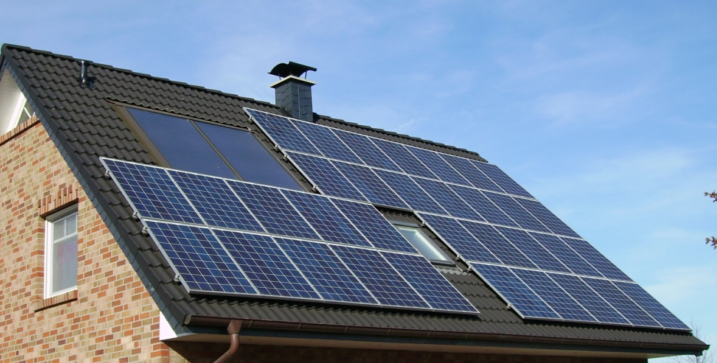Power output depends upon:

* Max power rating of the solar panel
* Direction it faces
* Angle inclination
* Amount of sun light it receives

What does the max power rating mean?

Your solar panels will have a number listed on the back that indicates how much power they will pump out during ideal conditions. This is called the maximum power rating. Labs that test solar panels calculate output using “peak sun,” or 1000 watts of sunlight per square meter of surface. That’s approximately equal to the power of the sun at noon, on a sunny day, at the equator. The power output in the UK will be less than this figure.

**Part one Collect data**

Collect the data you need

* direction roof faces (South, South West etc)
* approx. angle inclination
* number of 250 watt panels

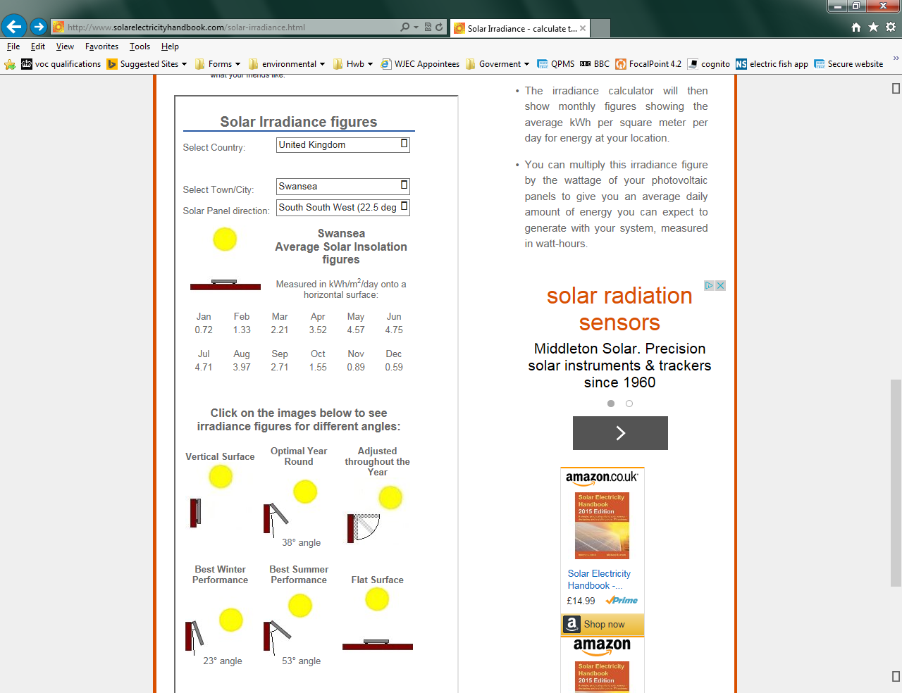**Part Two** **Using a spreadsheet to calculate output**

**Step one**

Work out the average monthly insolation figure. This is a measure of the amount of energy your panel receives from the sun.

Information for each month can be obtained using the calculator at:

<http://www.solarelectricityhandbook.com/solar-irradiance.html>

Enter this into your spreadsheet



**Step two**

Calculate the amount of solar energy you will get from a photovoltaic solar panel for an average day in any given month. This is the average monthly insolation figure.

average daily power = stated wattage of panel *x* average monthly insolation figure

You can enter a formula into the spreadsheet to do this.



**Step three**

Complete the spreadsheet to calculate the average amount of power generated each month and hence the total amount of power.

You can again enter a formula to do this.

# Activity 3.1

Organic molecules

|  |  |
| --- | --- |
| Figure Anthracene  File:Anthracene-diagram.png | Figure  http://www.sigmaaldrich.com/content/dam/sigma-aldrich/structure1/122/mfcd00004737.eps/_jcr_content/renditions/mfcd00004737-medium.png |
| Figure  http://images4.wikia.nocookie.net/__cb20080224135715/gcse/images/9/9c/Propene.jpg | Figure  http://upload.wikimedia.org/wikipedia/commons/thumb/8/80/Benzophenone-2D-skeletal.png/220px-Benzophenone-2D-skeletal.png |
| Figure  http://www.scienceforums.net/uploads/butanoic%20acid.jpg | Figure  http://www.mpbio.com/images/product-images/molecular-structure/02150690.png |
| Figure  http://www.pesticideinfo.org/ChemGifs/PC32818.gif | |
| Figure DDT  http://upload.wikimedia.org/wikipedia/commons/thumb/e/ed/DDT.svg/2000px-DDT.svg.png | Figure  http://www.chemsynthesis.com/molimg/1/big/0/822.gif |

**Decomposition of polychlorophenol**

Pesticides breakdown in soil. How long this will take depends upon a number of factors. The most important and effective way these compounds are removed from the environment is via biological decomposition.

The following diagram shows the decomposition by microbial action of the pesticide polychlorophenol (PCP). PCP has been used as an herbicide, insecticide, fungicide, algaecide, and disinfectant and as an ingredient in antifouling paint. Some applications were used in agricultural seeds (for non‑food uses), leather, masonry, wood preservation, cooling tower water, rope, and paper mills. Its use has declined due to its high toxicity.

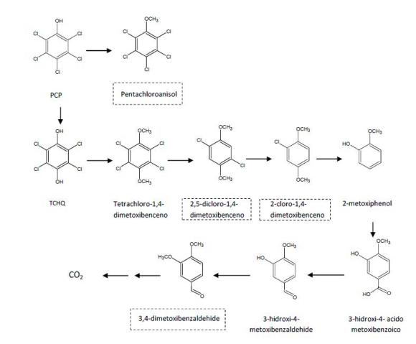

**B**

**A**

**C**

# Activity 3.3

You are directed to the secure website / pdf resources download / controlled assessment material/ Quantitative techniques Sample practical work

**U3-10S**

# Activity 3.4

You are directed to the secure website / pdf resources download / controlled assessment material/ Quantitative techniques Sample practical work

**U3-6S**

# Activity 3.3

You are directed to the secure website / pdf resources download / controlled assessment material/ Quantitative techniques Sample practical work

**pH U3-7S**

**alkalinity U3-04S**

**acidity U3-05S**

# Activity 4.2