

**Financial Markets:**

**A Guide**

**FINANCIAL MARKETS - A SIMPLE GUIDE**

Students often confuse savings and investment largely because journalists use both terms to refer to personal savings. **Savings** are a withdrawal from the circular flow of income and savers are rewarded with interest for lending their money for instance to banks and building societies. **Investment** is an injection into the circular flow and is the action of firms and governments buying new capital ie new machinery, hardware, buildings and infrastructure. Investment produces a multiplier effect in an economy.

Savers are lenders and firms and governments who want to invest are borrowers. Financial markets bring together lenders and borrowers; savers form a source/**supply of loanable funds** as lenders and borrowers need loans to invest and they **demand loanable funds**. In theory the point where the demand and supply of loanable funds intersect determines the long term interest rate in an economy. At its very simplest a commercial bank such as Barclays pays interest to savers and the bank lends out a proportion of the savers’ deposits to borrowers who if they are firms invest in capital equipment. The banks make profit by charging a higher rate of interest to borrowers than they give to savers.

The financial market is a term to describe where buyers and sellers meet to trade financial assets. There are three types of market which operate within the overall financial market, the money market, the capital market and the currency market.

**1. The Money Market**

The money market is where financial assets with up to one year left to maturity are traded these being treasury bills, bills of exchange etc. The main participants in this market are banks and the Bank of England. An important part of the money market is inter-bank lending – commercial banks lending to each other. **LIBOR**, which stands for London Interbank Offered Rate, is the benchmark interest rate that indicates borrowing costs between banks ie how much they charge in interest when they lend to each other. The Bank of England may intervene in this market as the **‘lender of last resort’.**

*Activity:*

*Investigate what is meant by the Bank of England’s role as the ‘lender of last resort’.*

*What are the other functions of the Bank of England?*

**2. The Capital Market**

The capital market involves the buying and selling of financial assets which have a payback/maturity which is greater than a year. It is important in the first instance to distinguish debt and equity in this market. **Debt** has to be paid back when it reaches maturity and holders of debt receive interest until the debt matures. Government long term debt (gilt edged securities or gilts for short) and issues of debt by business which include corporate bonds/debentures are traded on this market. **Equity** is a term describing share capital issued by PLCs such as Marks and Spencer and these shares are traded second hand on the Stock Exchange where their current market price is determined by the laws of demand and supply resulting from market traders buying or selling the shares. Holders of shares/equities can receive dividends from firms which are funded from their annual profits. The amount paid in dividend to shareholders is decided at the firm’s AGM and approved by the shareholders.

The capital market is divided into two parts, the **primary capital market** and the secondary capital market. The primary capital market is concerned with new issues of debt and equity and the **secondary capital market** is where already issued securities can be traded. Second hand markets enable otherwise very illiquid securities to be bought and sold. Few people would buy new issues of shares/equities if they could not easily sell them on the Stock Exchange whenever they wanted.

In the primary capital market the Debt Management Office (DMO) which is part of HM Treasury issues government bonds (gilts) to fund the gap between government income (mainly tax revenue) and government expenditure which forms the budget/fiscal deficit. PLCs such as BT also issue new debt (corporate bonds) and new shares, often with the aid of a Merchant Bank. Although debt and equity can be bought and sold by individuals both the primary and secondary markets are dominated by pension funds, insurance companies and sovereign wealth funds. All three of these **institutional investors** have large volumes of funds which they need to gain a return from. They construct a portfolio of financial assets which balances risk, liquidity and expected future returns.

In recent years a significant contributor to activity in the capital market has been the Bank of England through its policy of quantitative easing. Between 2009 during the financial crisis and 2016 the Bank of England purchased £435bn of largely public sector debt (gilts) from banks and financial institutions. In May 2019, UK public sector net debt (the national debt) was**£1,806.1 billion**equivalent to**82.9% of GDP and the Bank of England was holding just under 25% of this debt as a result of quantitative easing. Quantitative easing was designed to provide confidence and liquidity within the financial system so as to bolster the fragile recovery that followed the financial crisis. The quantitative easing transmission mechanism is shown below.**

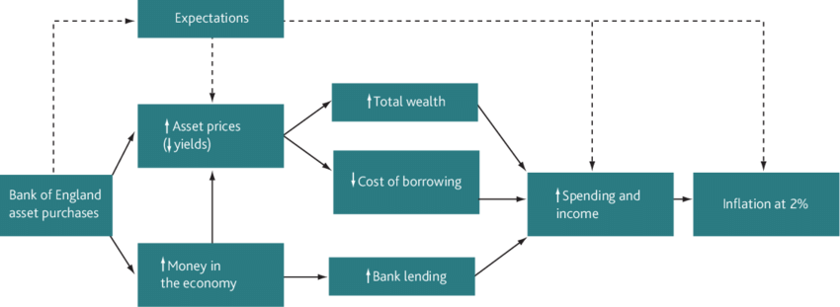

*Activity:*

*Write a detailed explanation of the transmission mechanism shown above.*

*In the context of QE explain the meaning of ‘tapering’ and ‘quantitative tightening’.*

**3. The Currency Market**

The currency market involves the buying and selling of foreign currencies. This is done to facilitate trade and to buy and sell assets denominated in different currencies. The currency market is divided into two parts; the **spot market** involves buying and selling of currency at the current market price which may fluctuate daily if the currency in question is like the pound and is allowed to float. A UK person about to leave on a holiday to France may go into a Post Office and will buy euros at the current/spot exchange rate. The **futures market** involves buying currency for delivery in the future at a price agreed now. This provides some protection for importers and exporters against unexpected future volatile fluctuations in the exchange rate. The futures market gives firms some degree of certainty over their future costs and revenues.

*Activity:*

*How might quantitative easing affect the exchange rate of a country’s currency?*

[*https://www.quora.com/How-does-quantitative-easing-affect-the-exchange-rate-of-a-currency*](https://www.quora.com/How-does-quantitative-easing-affect-the-exchange-rate-of-a-currency)

[*https://www.tutor2u.net/economics/reference/quantitative-easing-monetary-policy-update-2018*](https://www.tutor2u.net/economics/reference/quantitative-easing-monetary-policy-update-2018)

[*https://www.slideshare.net/tutor2u/1013-qe*](https://www.slideshare.net/tutor2u/1013-qe)

*Using a diagram explain how a central bank in an EU country would use its foreign exchange reserves to ensure that its currency stays in an exchange rate system such as ERM2.*

**LESSON PLAN**

**TOPIC: Marginal utility**

Marginal utility is a new part of the microeconomics course and this is a lesson where the topic could be applied to a real world example – charging for water. This lesson would follow the teaching of the topic and could be a 1 hour lesson.

**Preparation** – homework prior to the lesson.

Ask students to find out how their homes pay for their water supply. Hopefully some will have a water meter and others will have a fixed charge based on their home’s rateable value. Also ask students to research the reasons why there will be a growing imbalance between demand and supply of water over the coming decades in the UK.

**Lesson.**

Ask students to explain what they found out about how their household water supply is paid for.

Introduce to the students a scenario where there are two identical houses (a semi) which during a dry summer the lawn of one house is very brown and dry and the other is green.

**Discussion:**

Ask them to explain how different payment systems for water produce this outcome.

Ask them to explain this using the utility theory. The answers should be something on the lines that the household with a fixed water charge will consume water up to the point where marginal utility is 0 as water will essentially be a treated as a free good. The house with the meter will treat water like any other product and will have to consider the price of each litre of water consumed.

Discuss the reasons why water companies are worried about the imbalance between the demand and supply of water in the UK.

**Enrichment.**

Explain to the class the law of equi-marginal returns.

Although it is not in the specification it is nevertheless useful in this context justifying the adoption of water meters.

Explain the relevance of rationality to equi-marginal returns and introduce links to behavioural economics.

**Activity.**

Ask the class to work in pairs/threes to try to unravel these questions:

Why is water which is essential to life so cheap while diamonds which are mainly decorative are so expensive?

Ask them to try to use utility theory to answer the question.

**Enrichment:**

Explain to the class the paradox of value with a diagram.

