**Component 1 Narrative Writing - Possible Approaches**

Pupils can have issues with ‘fleshing out’ their ideas. Often their narratives can become formulaic and become a list of events, ignoring story conventions.

**Exercise 1**

Introduce the idea of story techniques/ narrative hooks.

Take a film/ book/ play they will be familiar with and reduce the plot to a sentence or two. For example:

Titanic= A massive ship hits an iceberg and sinks and lots of people die.

Romeo and Juliet= Two teenagers fall in love and can’t be together, so they end up killing themselves!

This can then lead to a discussion about what things are missing from these stories. What makes a story and gets people interested?

**Exercise 2:**

Record ideas as a list to use, adapt and refer back to.

Possible ideas elicited from Exercise 1 discussion

1. Structure- a clear idea or purpose to drive the narrative forward
2. Characterisation- primary/main and secondary and their role
3. Consideration of setting and its influence
4. Plot twists- foreshadowing or hinting at a problem or issue
5. Time and sequence- a logical (or not!) progression of events. This may include flashbacks/flashforwards. (Warning-tense control can be difficult)
6. Introduction of the new! This could be a character or event
7. Atmosphere- a sense of conflict or a building of tension
8. The narrative perspective
9. The narrative voice
10. Effective/convincing openings and endings

Possible extension tasks:

* Pupils to suggest the three ideas they think are most important for a good short story.
* Pupils to put the list of 10 (or however many ideas are on the list) in order of high importance to low importance. They then have to justify their choices to their peers.

**Exercise 3**

**Task: Use the clock as a planning tool to try to develop narrative ideas**

Once the pupils have the list, they can then start to plan their own ideas using the clock planning framework.

The idea of this is to spend 5 minutes on each section but they could write the story using the headings to guide them.

This can be easily adapted according to ability.

**Sample Titles for Narrative task**

* **The Birthday Party.**
* **Write a story that ends: …**

**It was all over for James but he’d survived.**

* **Write about a time that you felt isolated or alone.**
* **The First Day.**

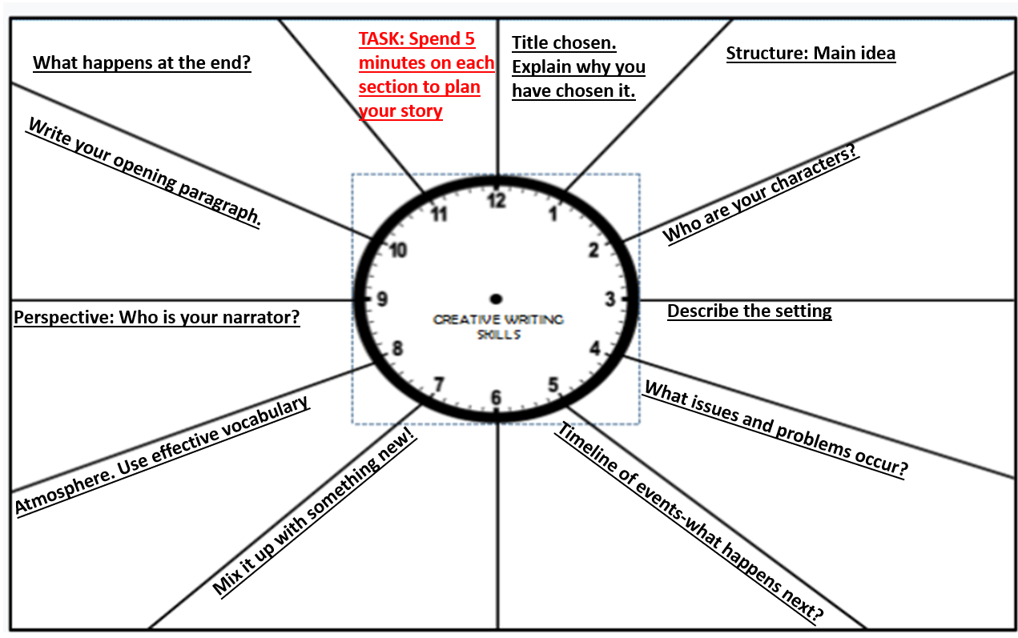

**Anecdotal Narrative Writing**

Another possible approach is using the idea of anecdotes as a catalyst for a short story.

Anecdote: noun – a short, amusing story about a real incident or person.

 What it **ISN’T**!

* Unrealistic
* Fantasy/Sci-fi/Horror
* Zombies/aliens/dragons/vampires etc
* Shoot ‘em up action
* Lots of violence

Other Things to Avoid

* Lots of characters
* Stories that stretch over a long period of time

What it **IS**

* Believable/authentic/convincing
* Perhaps something that has actually happened to you or a close family member
* An experience you remember well or an imagined experience that is told well
* Perhaps a funny/embarrassing story

Other Tips

* Like all good storytellers, exaggerate the truth for effect (tension, humour etc)
* Think about your reader. What can you do to engage them in the story? What you find interesting/funny/exciting, most likely will not be the same as what your English teacher or an examiner finds interesting/funny/exciting.
* It is better to tell a seemingly dull story in an interesting and exciting way rather than the other way round.
* Show what your characters are like; don’t just tell.
* Where applicable, follow the 5-part story structure of:
* Introduction, Rising Action, Climax, Falling Action, Resolution.
* In planning, write your resolution first so you know where your anecdote has to go.

And that’s before you even think about the technical accuracy of your writing.

**Show: Don’t Tell.**

Let’s take an annoying sibling as a stock character.

Telling = my brother was really annoying.

Showing (what he does) = Despite my pleading, my ‘wonderful’ 8 year old brother dropped my homework into the puddle.

Showing (how he does it) = with a glint of menace in his eyes... Nonchalantly

Showing (what he says) = “I told you not to tell Mum about the vase I broke.”

Showing (how he says it) = he slithered, with an eerie note of calm in his voice.

Which leaves us with:

Despite my pleading, my ‘wonderful’ 8 year old brother, with a glint of menace in his eyes, dropped my homework into the puddle, nonchalantly. “I told you not to tell Mum about the vase I broke,” he slithered, with an eerie note of calm in his voice.

Now it’s your turn:

Re-write the following **telling** sentences, using the 4 part **showing** structure:

My teacher was terrifying.

Showing (what he/she does) =

Showing (how he/she does it) =

Showing (what he/she says) =

Showing (how he/she says it) =

Write this as a paragraph.

Now try it again with this **telling** sentence:

My mum/dad was so embarrassing.

Showing (what he/she does) =

Showing (how he/she does it) =

Showing (what he/she says) =

Showing (how he/she says it) =

Write this as a paragraph.

And now try it with some characters from your own planned narratives:

Character 1:

Adjectives to describe them:

Paragraph that **shows** these adjectives, instead of **telling**:

Character 2:

Adjectives to describe them:

Paragraph that **shows** these adjectives, instead of **telling**:

**Beginnings…**

**The Slow Start**

Too often, students waste time writing about their morning routine at the start of a narrative. Instead, they would be much better served getting straight into the action.

Show students the following “slow start” as a warning to avoid this sort of introduction.

*BEEP! BEEP! BEEP!*

*The alarm on my phone rang out loudly but for the third time that morning, I hit snooze, rolled over and went back to sleep. 5 minutes later, it rang again so I dragged myself out of bed. I threw my covers onto the floor and looked in the mirror. I stretched and went into the bathroom. I brushed my teeth and then got into the shower. After washing my hair I got out, dried myself and put my deodorant on. I then got dressed before slowly walking downstairs. As I poured myself a bowl of Cornflakes, my brother ran into the room screaming, “We’re going to the beach!”*

Everything in this opening can be cut up until the final sentence and the narrative would be stronger for it. The best part of doing this would be that the writer would actually have an extra 5 minutes to develop characters, or come to a more satisfying resolution, or even to proof-read their narrative fully.

There’s nothing particularly terrible about the writing: it is accurate and characterises the narrator quite well but both these skills can be better shown throughout the narrative.

Other possible activities:

* read the opening lines of some exam exemplars (or their own practice narratives) and ask pupils to rate them from 1-5 or sort them into good/better/best
* explore the strengths and weaknesses of each opening in pairs/groups
* be the teacher- annotate the openings and note one successful characteristic and one area for improvement
* collaborative writing – improve one of the openings either in groups or as a whole class
* consult the experts – share openings from published short stories/novels and ask pupils to note down the different ways writers choose to start a story e.g. direct speech, description, humour, shock, something unexpected.
* encourage pupils to experiment with different strategies for starting a narrative

**And Endings…**

Task: Match the opening of the narrative to the ending. Which was the easiest and most difficult to match? Why?

It was just a normal morning for me. The bright sun was making my room glow and I could hear the birds chirping outside. I had a good feeling about that day, I didn’t know why but I just had a feeling.

The wedding had to be postponed of course but my sister should thank me. She and Jonathan split up, so it probably wouldn’t have been a very happy marriage anyway. Now I just have to pay back the money for those cups!

Today was the day I had spent my whole life dreaming about. Planning and perfecting every last detail. Little did I know my wedding day wouldn’t be what I had once dreamed.

I crossed the line. I was victorious. I turned around to see Joe had fell at the start, meaning not only did I beat him so did everyone else. This shall be a memory never forgotten.

The tea tray fell through the air as if it was suspended by some ethereal presence. Indeed, I hoped sincerely it was. The tea tray, if it heard my pleas, seemed to dismiss them and crashed down on the floor, the milk jug smashing into a million tiny pieces which scattered everywhere.

In the middle of the night I heard the front door open, so I looked through my window onto the street and see my dad sleepwalking. He walked half way down the street, had a wee and came back. I think he had a little too much to drink. That was a very memorable night.

Primary school. If I could I would go back to primary school waking every morning to the smell of burning toast, and orange juice. I loved primary school; I have hundreds of sad and happy memories. Sports day was my favorite.

She just dropped to the floor and there was a pool of blood surrounding her. I just remember letting out a pitch deafening scream. Will she die? Why has she been shot?

Matching Game Answers

This sort of task can help pupils consider such things as: the importance of narrative voice/perspective, what a cohesive plot means e.g. clear narrative progression and conclusion, tone e.g. the use of a humorous tone which continues throughout, effective openings and endings and tense consistency.

It was just a normal morning for me. The bright sun was making my room glow and I could hear the birds chirping outside. I had a good feeling about that day, I didn’t know why but I just had a feeling.

The wedding had to be postponed of course but my sister should thank me. She and Jonathan split up, so it probably wouldn’t have been a very happy marriage anyway. Now I just have to pay back the money for those cups!

Today was the day I had spent my whole life dreaming about. Planning and perfecting every last detail. Little did I know my wedding day wouldn’t be what I had once dreamed.

I crossed the line. I was victorious. I turned around to see Joe had fell at the start, meaning not only did I beat him so did everyone else. This shall be a memory never forgotten.

The tea tray fell through the air as if it was suspended by some ethereal presence. Indeed, I hoped sincerely it was. The tea tray, if it heard my pleas, seemed to dismiss them and crashed down on the floor, the milk jug smashing into a million tiny pieces which scattered everywhere.

In the middle of the night I heard the front door open, so I looked through my window onto the street and see my dad sleepwalking. He walked half way down the street, had a wee and came back. I think he had a little too much to drink. That was a very memorable night.

Primary school. If I could I would go back to primary school waking every morning to the smell of burning toast, and orange juice. I loved primary school; I have hundreds of sad and happy memories. Sports day was my favorite.

She just dropped to the floor and there was a pool of blood surrounding her. I just remember letting out a pitch deafening scream. Will she die? Why has she been shot?