A Level business

Price elasticity of demand

PRICE ELASTICY AND DEMAND

Businesses need to know what will happen if they raise or lower the price of their goods.

Simple supply and demand analysis tells us that, all things being equal, if a business raises the price of a product, the quantity demanded by its customers will fall and if they lower the price of the product the quantity demanded will rise

In order to make an informed decision the business will need to know by how much demand will fall or rise as a result of the increase or reduction in price. The reason for this is that they will want to know how it affects their revenue.

Revenue is calculated by multiplying the quantity of goods sold by the price. If the business raises its price there are three possible outcomes: revenue rises, revenue stays the same or revenue falls.

Clearly the first outcome is desirable, the second makes little difference and the final outcome is undesirable.

In the first case the percentage fall in sales will be lower than the percentage fall in the price. In other words an increase in price has resulted in a less than proportionate fall in sales and therefore revenue will rise. We can therefore say that demand is **inelastic**, i.e., there is not a big response to the rise in price.

In the second case the fall in sales is proportionate to the rise in price and revenue stays the same, demand has **unit elasticity**.

In the final case the percentage fall in sales is greater than the increase in price and as a result revenue falls. Consumers have responded significantly to the increase in price, possibly by making their purchases elsewhere. The demand for the product is **elastic.**

Elasticity can be calculated using the following equation:

The percentage change in quantity demanded

The percentage change in price

Example 1. Symonds Sausages Ltd raised the price of their premium sausages by 10% and sales fell by 5%. Therefore the elasticity of demand for premium sausages is:

-5%

10%

= - 0.5

As a rule the minus sign is ignored and the elasticity is stated as 0.5 or ½, as this is below 1 the elasticity of demand is said to be **inelastic.**

The formula can be restated as the change in quantity demanded ( ∆Q) divided by the change in the price ( ∆P) multiplied by the original price (P) divided by the original quantity (Q)

This is written as follows:

∆Q x P

∆P x Q

Example 2. Lighter Sounds Ltd reduced the price of their best-selling 50” television from £1200 to £1100. Monthly sales increased from 400 televisions to 500 televisions.

Using the formula this gives:

100 x 1200

-100 x 400

= 3

Since this is greater than 1 we can say that the demand for these television sets is elastic. Furthermore, Lighter sounds benefit greatly from this as their revenue increased from £480,000 to £550,000.

It should now be clear that, if the demand for a product is elastic (greater than 1) it makes sense to reduce the price, whereas if the demand is inelastic (less than 1) it makes sense to increase the price. If the demand is unity, i.e., exactly 1, it makes no difference if the price is increased or reduced, revenue will remain the same.

INCOME ELASTICITY OF DEMAND

A business will also want to know how rises or falls in income affect the demand for their products. Throughout most of the period from 1948 to 2007 incomes in Britain increased and businesses respond to this by providing higher value goods and services to consumers. However, the financial crisis of 2007 began a period of time when incomes fell and they have only recently begun to recover. This period of low economic growth proved to be an opportunity for businesses that specialised in selling goods at discount prices. Pound shops and supermarkets such as Aldi and Lidl flourished at the expense of more established businesses such as Tesco.

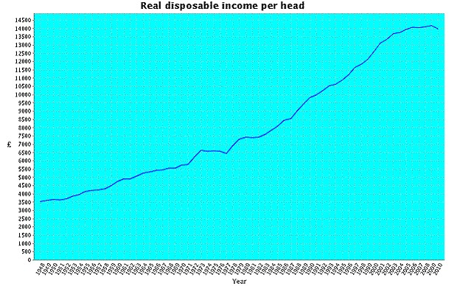

Source: <http://www.telegraph.co.uk/finance/economics/8414447/How-UK-incomes-have-risen-and-fallen-since-1948.html>

Income elasticity of demand measures the way that the quantity demanded of a good varies with changes in income. It can be calculated in a similar way to price elasticity of demand.

The formula that we use is:

The percentage change in quantity demanded

The percentage change in income

The formula can also be written as follows, where Q once again stands for quantity and Y stands for income:

∆Q x Y

∆Y x Q

If income elasticity is positive for a particular product it is said to be a normal good. In other words, as incomes rise people will buy more of it. If income elasticity is greater than 1, i.e., people spend proportionately more of their income on the product as their income rises the good is known as a luxury good. On the other hand if expenditure on a good falls as income rises, income elasticity will be negative and the good will be classified as an inferior good.

Example 1. Symonds sausages have found that if incomes increase by 5% the demand for their premium sausages increases by 10%.

Therefore the income elasticity of demand for Symonds premium sausages is:

10%

5%

= 2

Since the percentage increase in the sales of premium sausages is greater than the percentage increase in incomes we can conclude that they are luxury goods and that if incomes continue to rise Symonds Ltd should expect to sell even more of their premium sausages. In order to be prepared for this the company might have to consider such things as purchasing new machinery, finding new premises and looking for increased supplies. All of these things need to be planned for, since they take time to implement. Knowledge of the income elasticity of demand for their products is therefore of considerable importance businesses like Symonds Ltd.

Example 2. Lighter Sounds are expecting average incomes to rise over the next year from £35,000 a year to £36,000 a year. They anticipate that the sales of their smaller size television sets will fall from 1000 sets a year to 800 as customers go for the larger sizes.

The income elasticity of demand is:

- 200 x 35,000

1000 x 1000

= -7

Since the income elasticity is less than zero, we can conclude that the income elasticity is negative and that small televisions are inferior goods.

If Lighter Sounds Ltd anticipate that incomes will continue to rise they will clearly need to stock less of this type of good and concentrate on the normal and luxury goods in their product range.